Type 'help;' or '\h' for help. Type '\c' to clear the current input statement.

mysql> -- 1. Create the database

Query OK, 0 rows affected (0.00 sec)

mysql> DROP DATABASE IF EXISTS ecommerce_demo;

Query OK, 4 rows affected (0.05 sec)

mysql> CREATE DATABASE ecommerce_demo;

Query OK, 1 row affected (0.01 sec)

mysql> USE ecommerce_demo;

Database changed

mysql>

mysql> -- 2. Create tables

Query OK, 0 rows affected (0.00 sec)

mysql> CREATE TABLE customers (

-> customer_id INT PRIMARY KEY,

-> name VARCHAR(100),

-> email VARCHAR(100),

-> city VARCHAR(100)

-> );

Query OK, 0 rows affected (0.02 sec)

mysql>

mysql> CREATE TABLE products (

-> product_id INT PRIMARY KEY,

-> product_name VARCHAR(100),

-> price DECIMAL(10,2)

-> );

Query OK, 0 rows affected (0.02 sec)

mysql>

mysql> CREATE TABLE orders (

-> order_id INT PRIMARY KEY,

-> customer_id INT,

-> product_id INT,

-> quantity INT,

-> order_date DATE,

-> FOREIGN KEY (customer_id) REFERENCES customers(customer_id),

-> FOREIGN KEY (product_id) REFERENCES products(product_id)

-> );

Query OK, 0 rows affected (0.03 sec)

mysql>

mysql> -- 3. Insert sample data

Query OK, 0 rows affected (0.00 sec)

mysql>

mysql> -- Customers

Query OK, 0 rows affected (0.00 sec)

mysql> INSERT INTO customers VALUES

-> (1, 'Person One', 'abc1@example.com', 'Dubai'),

-> (2, 'Person Two', 'abc2@example.com', 'Abu Dhabi'),

-> (3, 'Person Three', 'abc3@example.com', 'Sharjah');

Query OK, 3 rows affected (0.00 sec)

Records: 3 Duplicates: 0 Warnings: 0

mysql>

mysql> -- Products

Query OK, 0 rows affected (0.00 sec)

mysql> INSERT INTO products VALUES

-> (101, 'Laptop', 2500.00),

-> (102, 'Smartphone', 1500.00),

-> (103, 'Headphones', 300.00);

Query OK, 3 rows affected (0.00 sec)

Records: 3 Duplicates: 0 Warnings: 0

mysql>

mysql> -- Orders

Query OK, 0 rows affected (0.00 sec)

mysql> INSERT INTO orders VALUES

-> (201, 1, 101, 1, '2025-08-01'),

-> (202, 2, 102, 2, '2025-08-02'),

-> (203, 1, 103, 3, '2025-08-03'),

-> (204, 3, 102, 1, '2025-08-04');

Query OK, 4 rows affected (0.00 sec)

Records: 4 Duplicates: 0 Warnings: 0

-- 1) Select all customers from Dubai (basic SELECT + WHERE)

-- 2) List all orders with customer names and product names (INNER JOIN)

-- 3) Calculate total amount spent by each customer (JOIN + SUM + GROUP BY)

-- 4) Find customers who have ordered more than 2 items in total (subquery + HAVING)

-- 5) Create a view for customer order summary (view creation)

-- 6) Query the view to see the summary

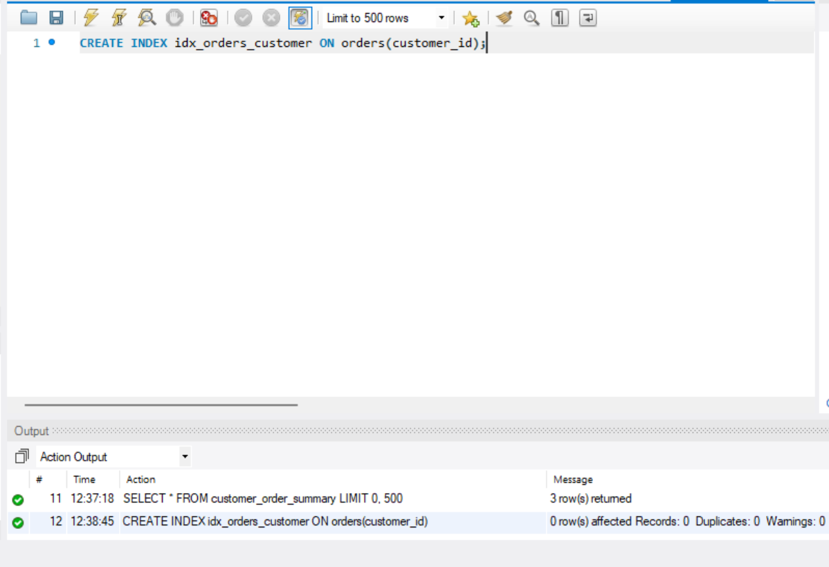

-- 7) Optimize: Create index on orders.customer_id to speed up JOINs

-- 8) Optional: Show orders sorted by order_date descending